Intermodal transport in Poland in 2022
Intermodal transport allows to create modern transport chains that combine two or more modes of transport into one system. It is based on nodes representing the interconnection points of the various modes of transport involved in the transport of goods without changing the loading unit. The greater number of nodes (land and maritime terminals), the easier it is to access the connection network.
2.7%
Increase in transshipments
at intermodal terminals compared to 2021

Intermodal terminal is a place that allows for quick and safe reloading of units between
two different types of transport modes. There were 35 active terminals located in Poland
in 2022, including:
In 2022, there were 35 active terminals, i.e. 4 less than
in the previous year
– 4 handled sea-rail, sea-road shipments (maritime terminals),
– 31 handled rail-road transports (land terminals).
Map 1. Location of intermodal terminals in 2022

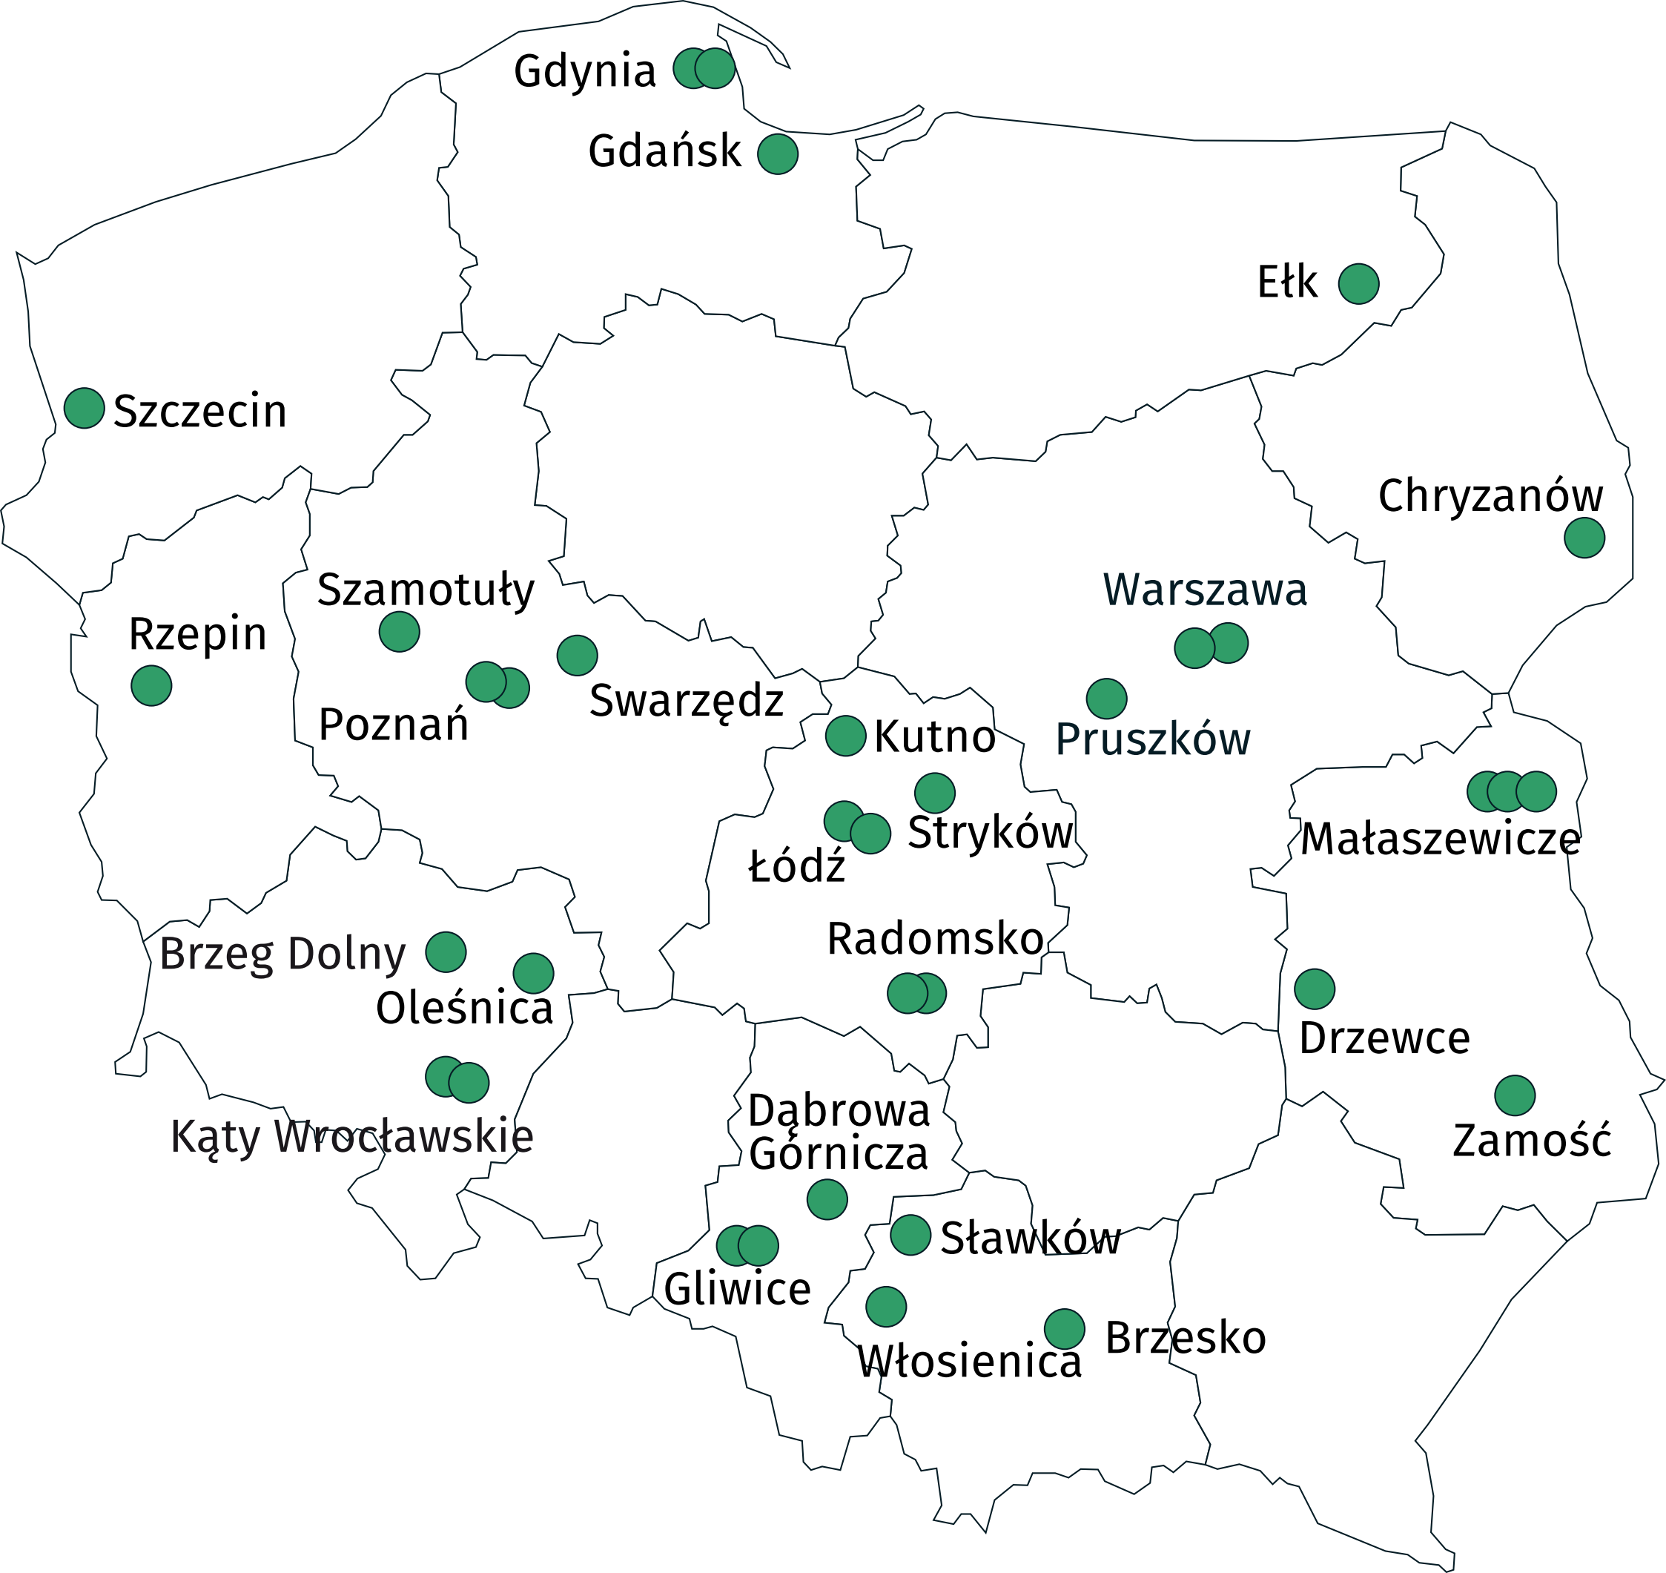

Maritime terminals infrastructure
The length of reloading quays at maritime terminals in 2022 was 5.4 km in total, of which 85.7% were quays for handling cargo units in the lo-lo system.
The capacity of storage yards per year at maritime terminals decreased by 0.5%, and
at land terminals increased by 4.3%
The parking and maneuvering area was 6.1 ha, and the total storage area of terminals
– 183.0 ha, of which 80.4% of the area intended for containerized units. The capacity of the storage yards was 100.2 thousand TEU.
Maritime terminals had a total of 17.0 km of track for standard gauge railways, of which 70.8% was intended for direct loading/unloading of intermodal units. The average length
of the train set (number of wagons) serviced simultaneously at the maritime terminal was
71 pieces.

Land terminals infrastructure
In 2022, the parking and maneuvering area at land terminals covered a total of 24.4 ha, and the total storage area of the terminals – 97.4 ha, of which 82.3% of the area intended for containerized units. The capacity of the storage yards was 139.1 thousand TEU.
In 2022, land terminals had a total of 100,5 km of track for standard gauge railways, of which 39.0% were intended directly for loading/unloading intermodal units. Average length of train set (number of wagons) serviced simultaneously at the inland terminal was 30 pieces.

Table 1. Handling equipment at intermodal terminals in 2022
Specification | Maritime terminals ª | Land terminals ^{b}
Specification | in units
Cranes | 109 | 16
wharf | 28 | –
gantry | 5 | 12
road container | 76 | 4
Coastal and mobile cranes | 6 | 2
Trucks | 26 | 121
front boom | 17 | 96
others ^{c} | 9 | 25
Technological tractors | 163 | 9
Low semi-trailers | 55 | –
Others | 46 | 1
a Data for 4 maritime terminals.
b Data for 23 land terminals.
c Container shuttles, side containers, front stackers.

Transshipments at maritime and land intermodal terminals
The total annual throughput capacity of intermodal transport terminals was 8.7 million TEU, including 4.9 million TEU at maritime terminals, and at land terminals – 3.8 million TEU.
In 2022, a total of 84.2 million tonnes of containerized cargo were transhipped at intermodal terminals
In 2022, a total of 84.2 million tonnes of containerized cargo were transhipped at intermodal terminals, i.e. 2.7% more than in the previous year. 40' containers (65.3%) prevailed in the
total number of transhipped containers at maritime and land terminals. The share of 20' containers was 25.4%, 45' and bigger containers – 5.8%, and 30' – 3.5%.
29.7 million tonnes were transported to/from intermodal terminals by sea (which amounted
to 35.2% of the total goods transhipped at maritime and land terminals), by road – 25.9 million tonnes (30.8%), and by rail – 28.6 million tonnes (34.0%).
In 2022, in intermodal transport 62,3% of cargo was unknown (an increase by 7.3 percentage points compared to 2021). Following greater share had mixed goods: a set of various types
of goods transported together – 11.2% (decrease by 3.2 pp), metals, finished metal products (excluding machinery and equipment) – 6.6% (increase by 4.8 pp), product from the group chemicals, chemical products, artificial fibers; rubber and plastic products; nuclear fuel
– 5.3% (increase by 0.2 pp), food products, beverages and tobacco – 2.9% (decrease
by 1.9 pp) and others – 5.6% (increase by 1.7 pp).
Chart 1. Structure of goods in containers transported to/from intermodal terminals
by groups of goods in 2022 (based on the number of tonnes)

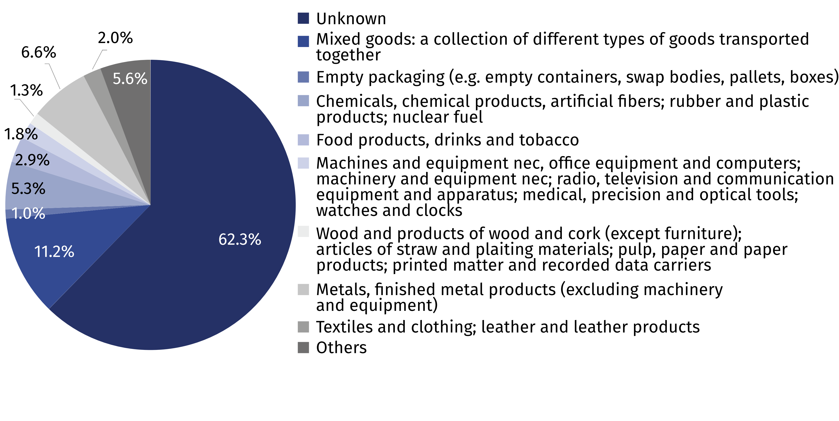

Transport of goods in containers by intermodal road transport
In intermodal road transport, the share of national transport amounted close to 99%
In 2022, over 25 million tonnes of goods were transported by intermodal road transport
in containers. The share of domestic transport amounted to 98.6%. In national transport most goods were transported to/from Voivodships: Łódzkie (26.2%), Pomorskie (15.4%),
Śląskie (12.3%), Dolnośląskie (11.2%) and Małopolskie (10.4%). A decrease in the transported tons of containerized cargo compared to the previous year was recorded in the following Voivodships: Dolnośląskie, Śląskie, Pomorskie, Świętokrzyskie, Lubuskie, Kujawsko-pomorskie and Wielkopolskie. In the remaining voivodships, more goods were transported than
in the previous year.

Chart 2. In 2022 the share of voivodships in the transport of containerized goods by intermodal road transport (based on the number of tonnes) ^{ab}

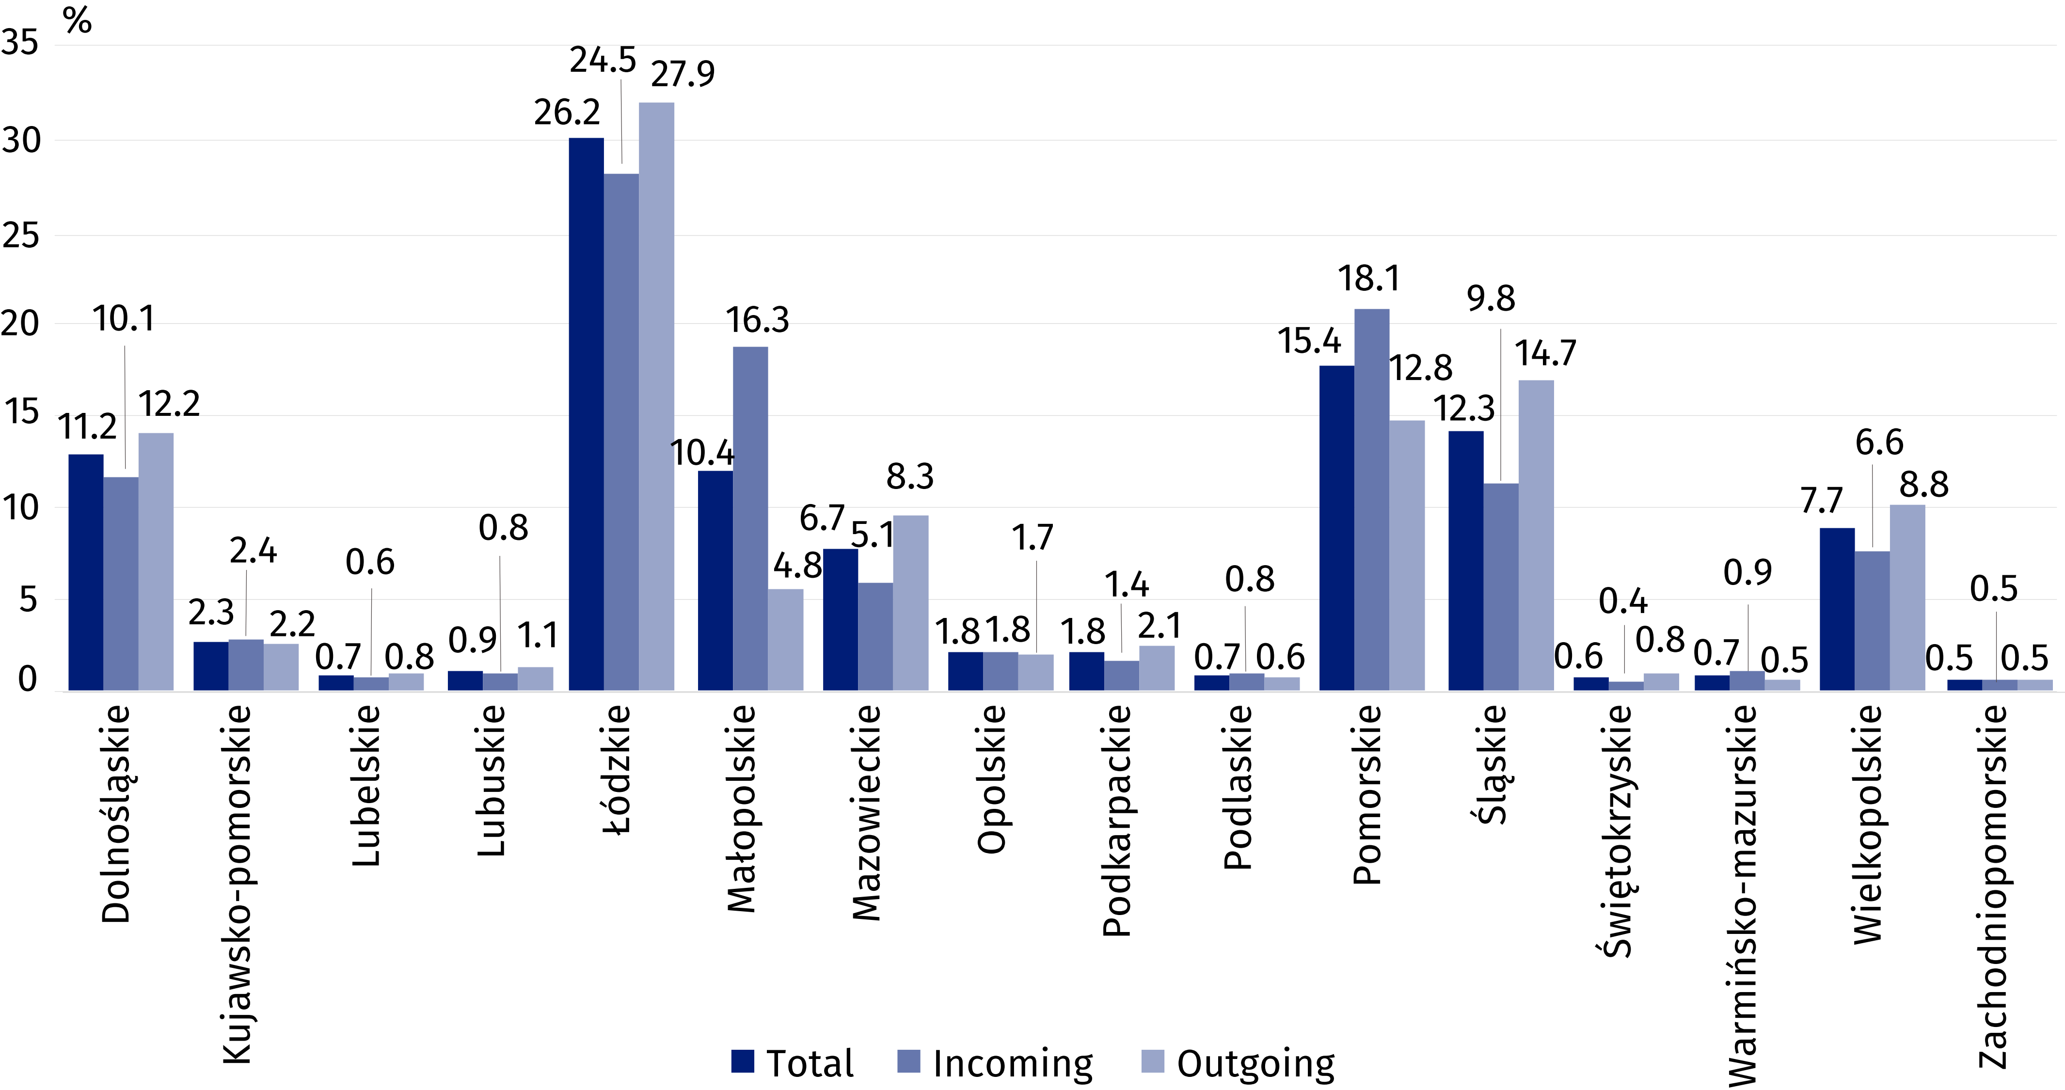
a The data include transport to/from intermodal terminals located in Poland.
b Estimated data.

When quoting data from the Central Statistical Office, please include the following information: "Source of data from the Central Statistical Office", and in the case of publishing calculations made on the data published by the Central Statistical Office, please include the following information: "Own study based on Central Statistical Office data".

Prepared by:  Statistical Office in Szczecin  Deputy director Katarzyna Dmitrowicz-Życka  Phone: (+48 91) 459 77 00 | Issued by:  The Spokesperson for the President  of Statistics Poland  Karolina Banaszek  Phone: (+48) 695 255 011
Press Office  Phone: (+48 22) 608 38 04  e-mail: obslugaprasowa@stat.gov.pl |   stat.gov.pl/en/

@StatPoland

@GlownyUrzadStatystyczny

gus_stat

glownyurzadstatystycznygus

glownyurzadstatystyczny
Related information
Transport – activity results in 2021
Data available in databases
Domain Knowledge Base Transport and Communications
Terms used in official statistics
Container ISO
Intermodal terminal

